**PRACTICAL: 2**

**AIM:** Implement File Transfer Protocol in LAN and WAN.

1. *Simple User- FTP Server in LAN*
2. *University FTP example along with access permission in LAN*
3. *University FTP example along with access permission in WAN*

**THEORY:**

FTP:-FTP(file transfer protocol) is a network protocol for transmitting files between computers over transmission control protocol/internet protocol (TCP/IP) connections. FTP is considered an application layer protocol.

FTP is a client –server protocol that relies on two communications channels between the client and server: a command channel for controlling the conversation and a data channel for transmitting file content.

FTP sessions work in 2 modes: 1.Active mode

**2. Passive mode**

**TOPOLOGY:**

**1.**

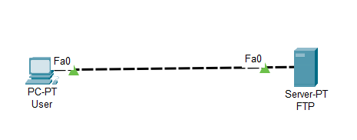

| **2.**      **3.** |
| --- |

**Commands:**

1. *Simple User- FTP Server in LAN*

Take one Computer and one Server and give name USER ( ip address: 192.168.1.1) and

FTP ( ip address: 192.168.1.2) respectively. Also on FTP service of server.

Create one file on USER and with using command upload it to the SERVER.

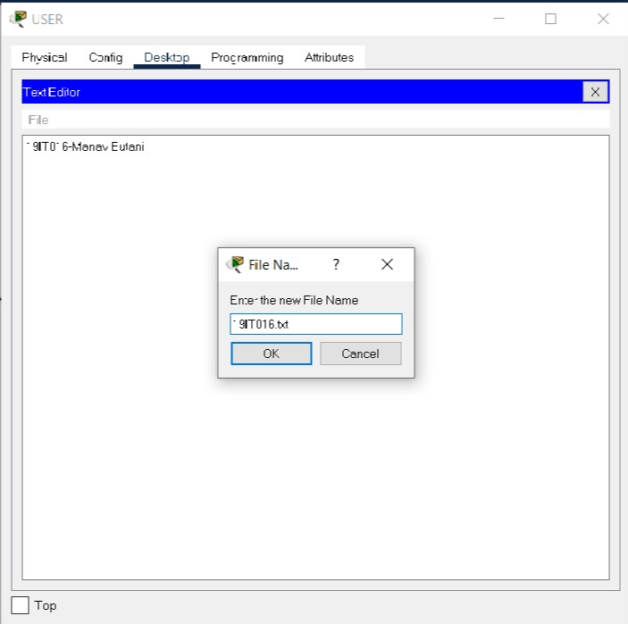

Open command prompt of USER.

For Connection Establishment write ftp and Server Ip address

Ex: ftp 192.168.1.2

And using put command upload file on to the server.

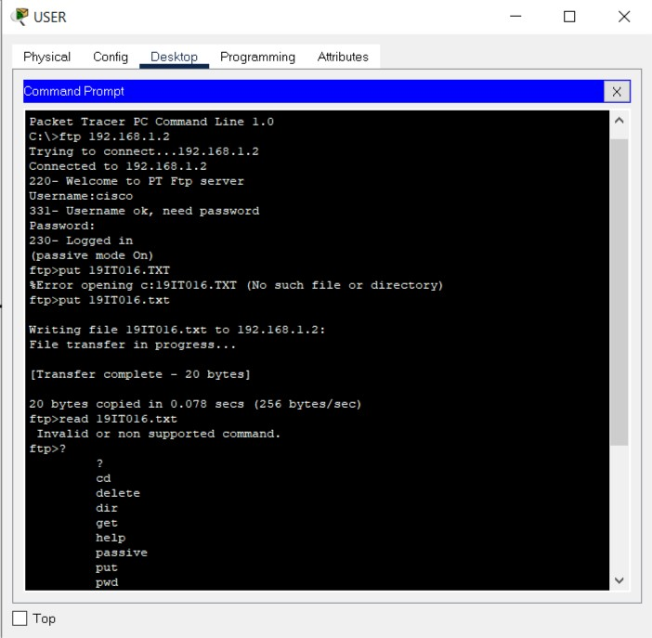

Now on FTP our 19IT016.txt file is uploaded.

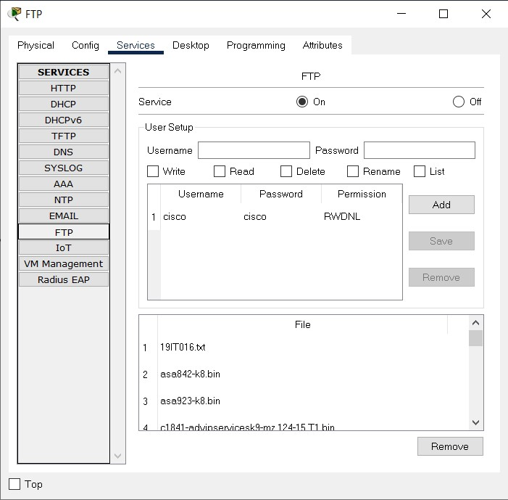

1. *University FTP example along with access permission in LAN*

Take 4 PC , 1 server , 1 Switch

PCs’ IP address:

Admin: 192.168.1.4

Student: 192.168.1.1

F_1: 192.168.1.3

F_2: 192.168.1.2

Server IP address: 192.168.1.5

As per given task we have created Users Entry on FTP server.

Faculty has read and writes permissions

Student has read only permission

Admin had Read, Write, Delete, Rename and List permissions.

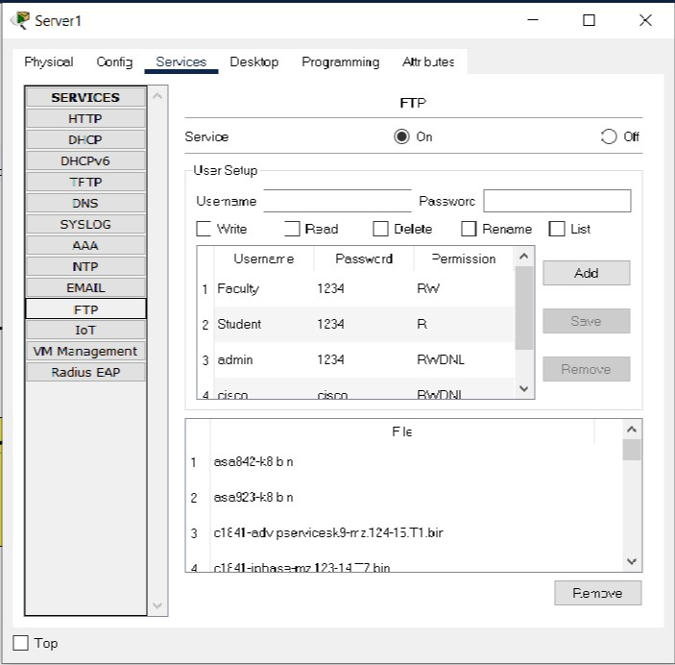

Admin creates one file and upload (writes) it to the server.

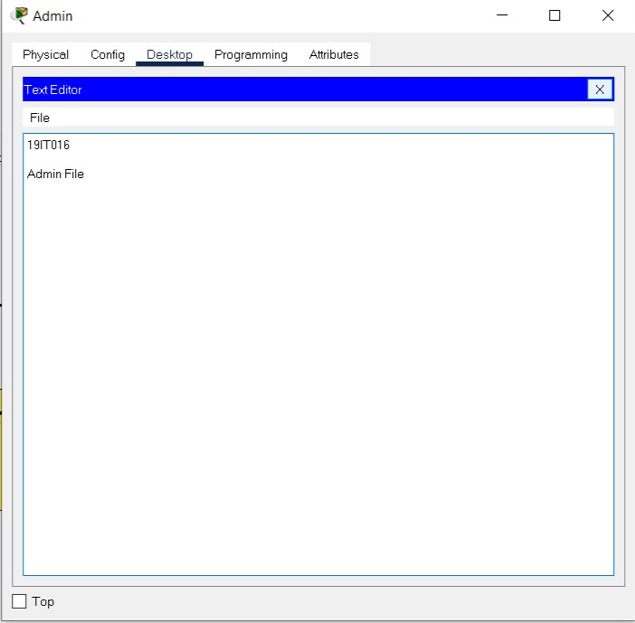

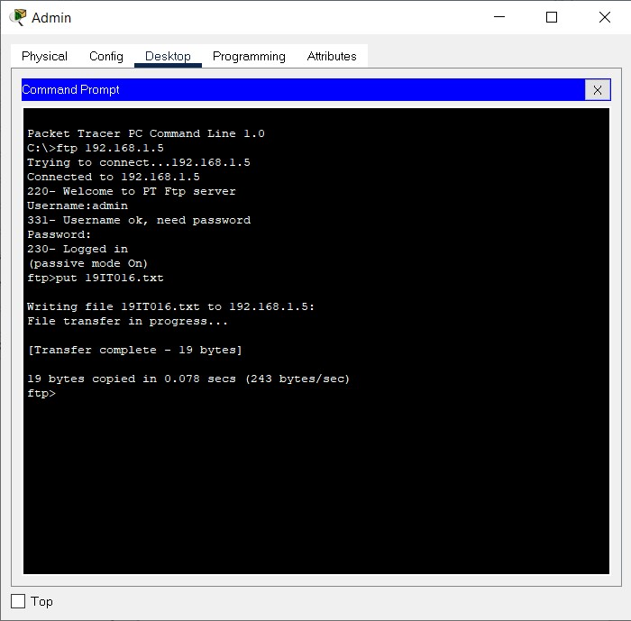

From Student PC we are trying to List out files on server and also try to delete file

But we unable to do and get message permission denied.

So we have read permission then we are getting the file.

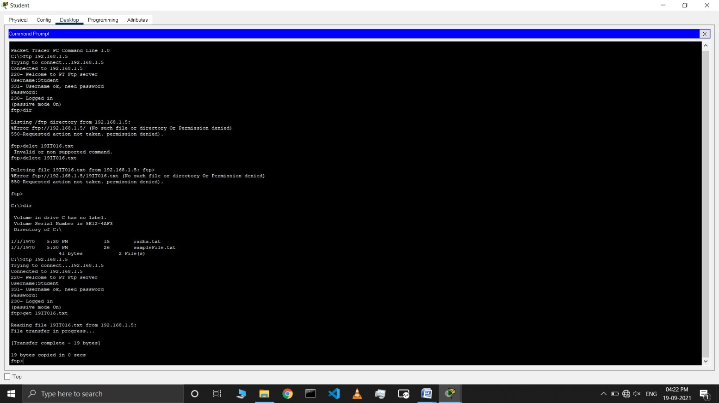

We are creating file and try to upload it from student PC and we get an error because we don’t have write permission.

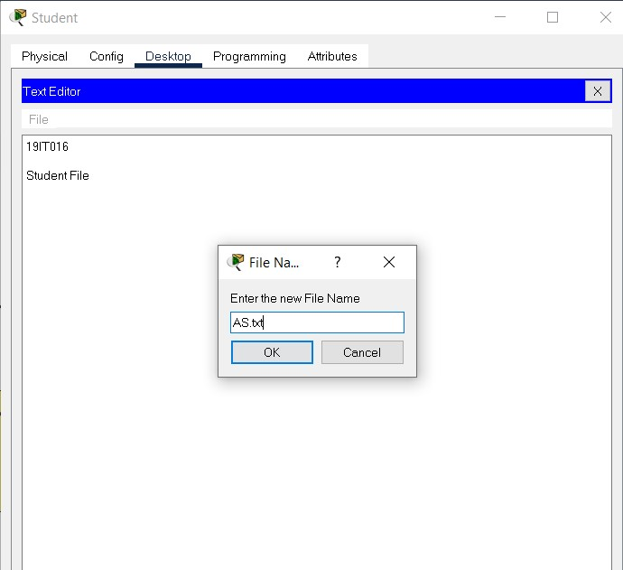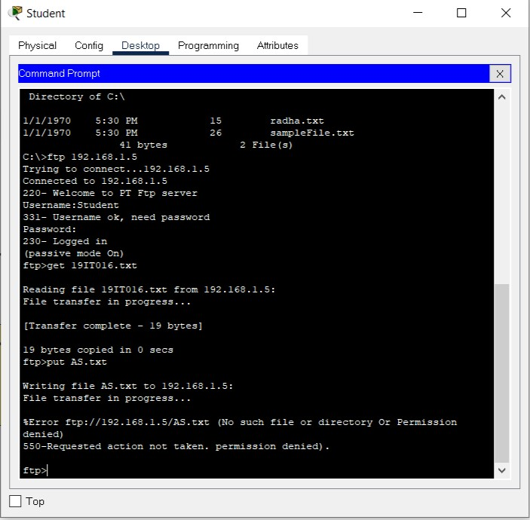

As same as student Faculty can’t list of the files, unable to rename and delete, but can Read and write the file

1. *University FTP example along with access permission in WAN*

Take 4 PCs, 1 server, 1 Router, 2 Switches

PCs’ IP address:

Admin: 192.168.1.4

Faculty: 192.168.1.1

S_1: 10.0.0.1

S_2: 10.0.0.2

Router:

Giga Ethernet Port 0/0: 192.168.1.6

Giga Ethernet Port 0/1: 10.0.0.3

Server IP address: 192.168.1.5

Assignment of Default Gateway:

Server, Admin, Faculty are in same network which is connected to Giga Ethernet Port 0/0

So assign Default Gateway 192.168.1.6 of all Components

Students have different network which is connected to Giga Ethernet Port 0/1 so assign

So assign Default Gateway 10.0.0.3 of all Components of student network.

As per given task we have created Users Entry on FTP server.

Faculty has read and writes permissions

Student has read only permission

Admin had Read, Write, Delete, Rename and List permissions.

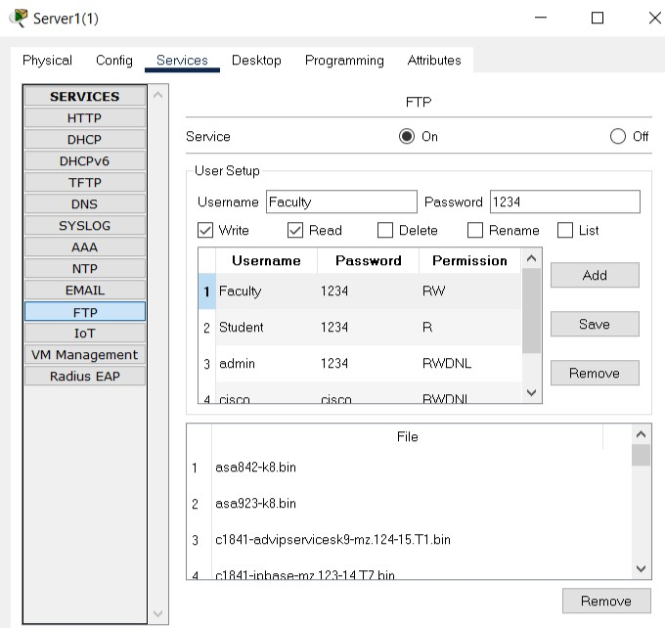

Admin creates one file and upload (writes) it to the server.



Renames 19it016.txt to manav.txt

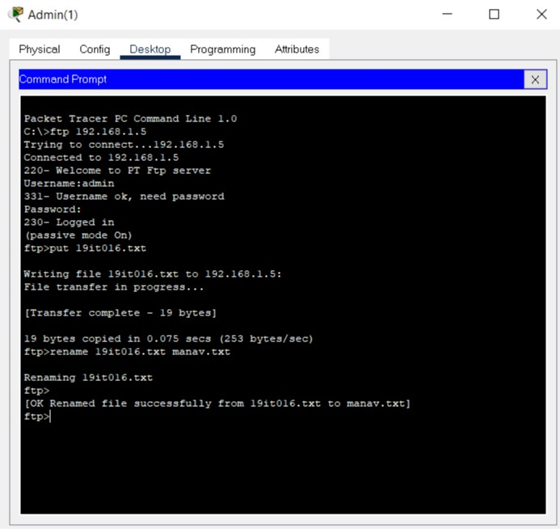

From the Faculty PC upload file on server.

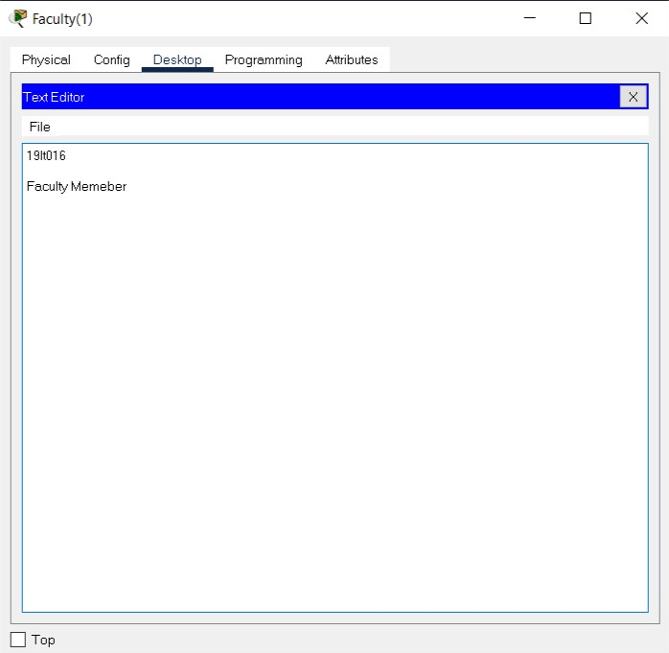

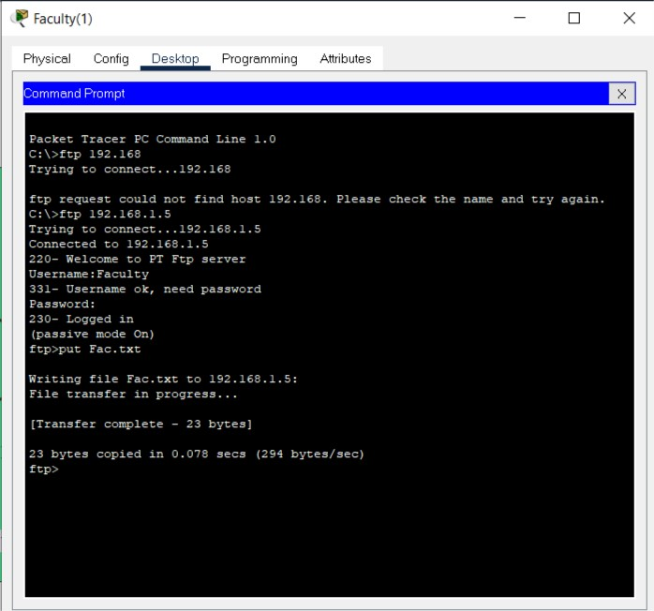

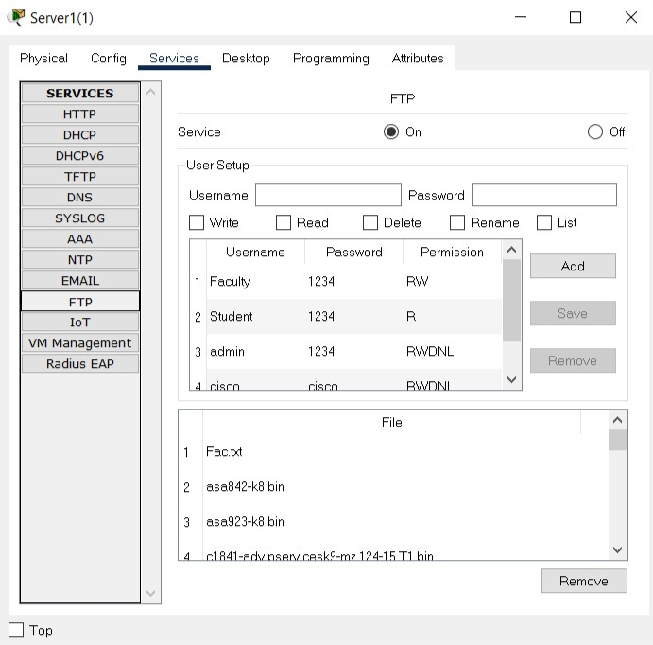

From student pc we are reading Manav.txt and Fac.txt.

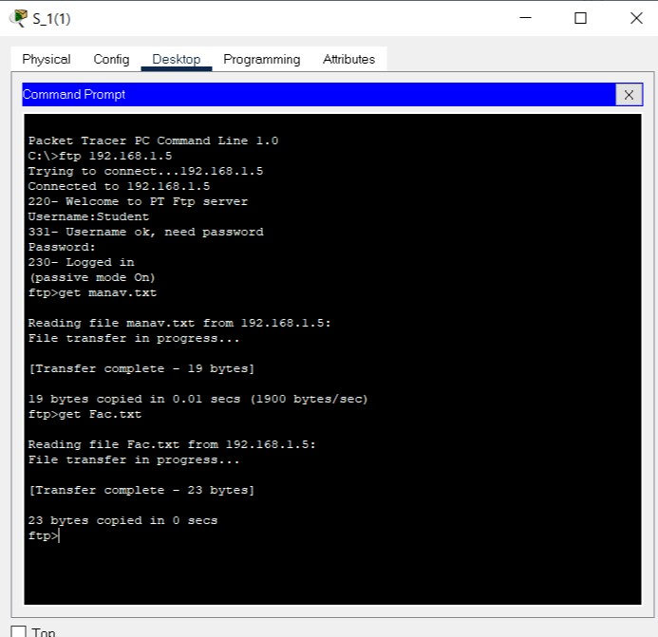

**OUPUTS:**

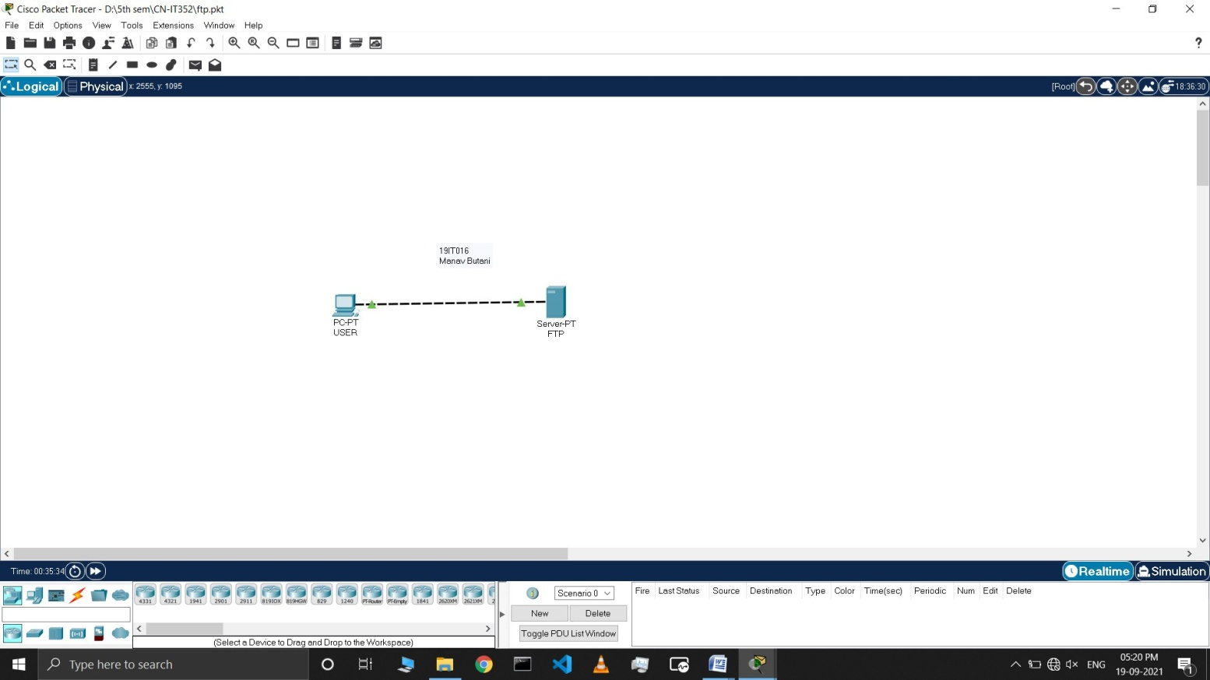

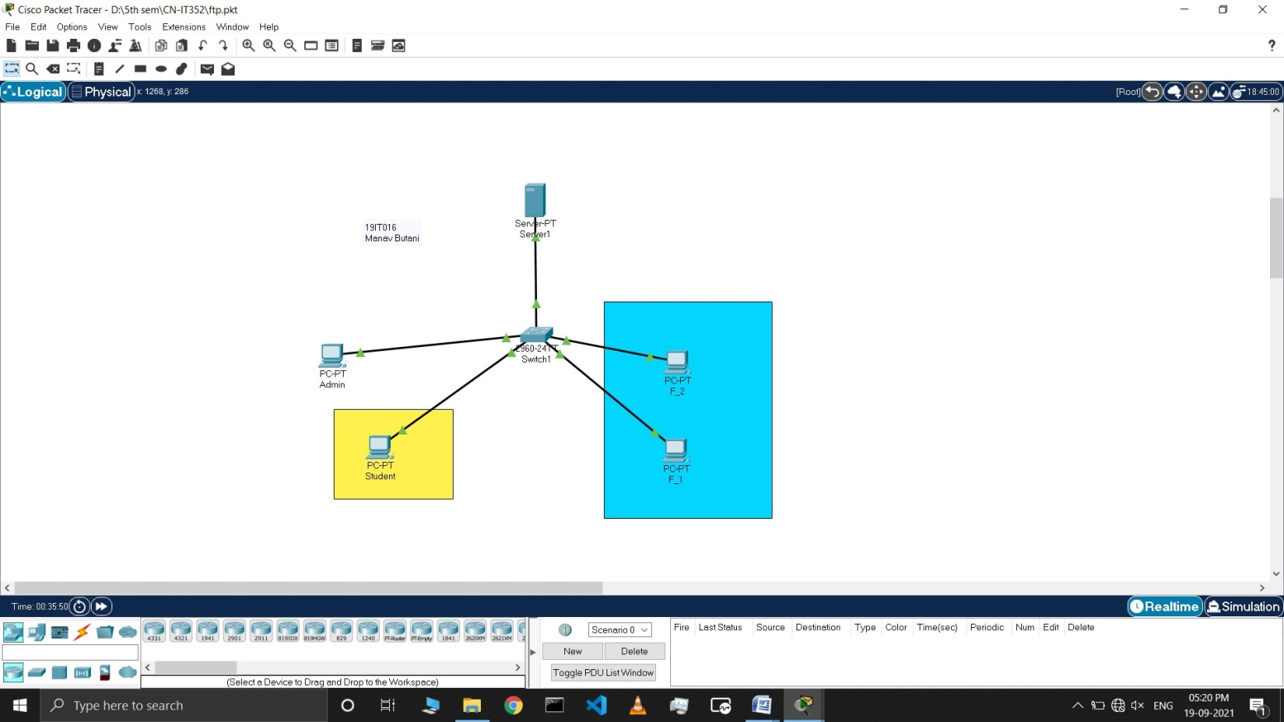

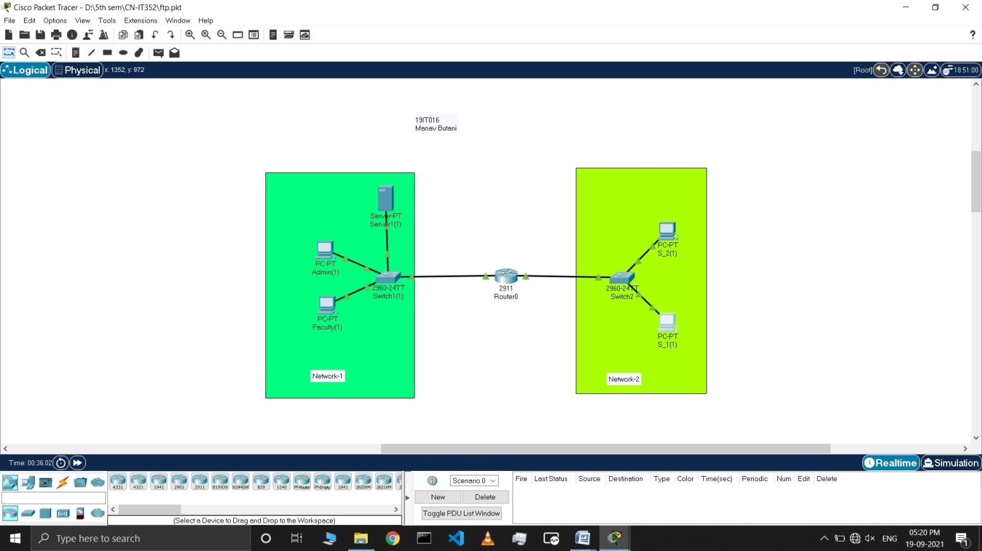

**LATEST APPLICATIONS:**

* Organizations use FTP to allow employees to share file across different locations and branch offices
* Employees use FTP to securely share files with coworkers and external business partners
* IT teams use FTP to transfer data back to disaster recovery (DR) sites
* Webmaster teams use FTP to transfer WebPages, web application files, and images to their web server

**LEARNING OUTCOME:**

1. How to use Server FTP service default user and Manual User and FTP commands
2. How to configure different network topology
3. Also server requires Default Gateway in WLAN.